**LONDON STARS EDUCATION CENTRE**

**P.1 CLASS EASTER PACKAGE FOR TERM I 2024**

**Name: ………………………………………………………………………………….**

**English**

1. **Which letter comes after?**

D _______ Y ________ Q ________ V _________

1. **Arrange these letters to make correct words.**

hcira ____________ betla ___________ kobo __________

1. **What is this?**

This is a book.

______________________________________________

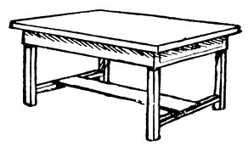

_______________________________________________

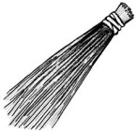

_______________________________________________

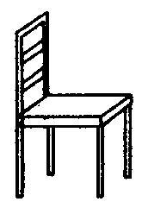

______________________________________________

1. **Fill in the missing letters**

(a)t ____ ble (b) do______ tor

1. **Write these words correctly.**

(a)nus ____________________ (b)xob _____________________

1. **Arrange in ABC order**

book, sun, apple, table

___________________________________________________________

1. **Fill in the gaps with “a”or “an”**

(a)The girl has _____________ duster.

(b)Sarah bought _____________ egg.

**Mathematics**

1. **Draw more beads to make the number given.**
2. = 3 b) = 5 c) = 2
3. **Add these sets.**

+ =

1. + 1 = ______
2. A ____________________ is a collection of things.

(set, shape)

1. **Add these numbers.**
2. 3 + 1 =
3. 4 + 2 =
4. 1 + 4 =
5. **Fill in the missing numbers.**

1, 2, _____, 4, ____, 6, _____, 8, ____, 10

1. **Draw these sets.**
2. A set of 3 eggs.
3. A set of 5 balls.
4. **Write the number name for;**

6 = six4 = ___________________________

7 = __________________ 8 = ___________________________

9 = __________________

1. **Form new sets.**

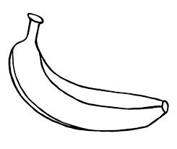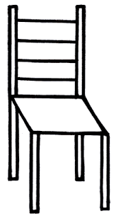

1. **Circle the bigger number.**

9 or 12

**Literacy II**

1. **Sound these to your parent.**

ch sh oo ee

1. **Make words with these sounds.**

oo: ___________ ___________

ee: ___________ ____________

sh: ___________ _____________

ch: ___________ _____________

1. 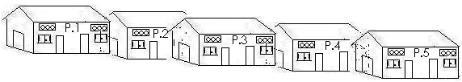**Fill in with a correct word.**

At ___________ we sit on the _________.

The teacher gives us ___________, _________

and ____________ to write.

(books, rulers, chairs, pencils, school)

1. **Read story and answer the questions.**

A cow is a domestic anima. It has four legs. It lives in a kraal. It’s young one is called a calf. It gives us meat and milk. A cow is a good animal.

**Questions**

1. A _______________ is a domestic animal.
2. A cow lives in a _____________________
3. It gives us ________________ and ________________
4. Draw a cow and a calf below.

**RE**

1. **Underline the good behaviour.**

greeting, stealing, loving, killing, obeying

1. Name two people God gave us at home.
2. __________________________________________________
3. __________________________________________________
4. What is your religious name?

________________________________________________________

1. **Match correctly.**

Peter peace

Emmanuel rock

Irene God is with us.

1. **Name the body gifts from God.**

|  |  |  |
| --- | --- | --- |
| D:\DESKTOP BACKUP\assesst\SAM PICTURES\SAM PICTURES2\Human body parts\hand.jpgD:\DESKTOP BACKUP\assesst\SAM PICTURES\SAM PICTURES2\Human body parts\hand.jpg | D:\DESKTOP BACKUP\assesst\SAM PICTURES\SAM PICTURES2\Human body parts\head.bmp | C:\STAICY 2021\ALL NISSI\DISAN PICS\pics\nose doll.png |
|  |  |  |

1. 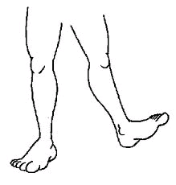**Fill in with a correct word.**
2. We use __________ for __________________

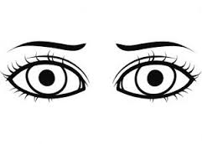

1. 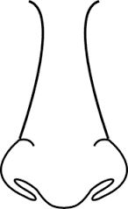We use __________ for _________________and

__________________ for _________________

1. Name two people God created.
2. _______________________________________________
3. ________________________________________________
4. On which day do moslems go for prayers?

________________________________________________________

1. Who was the mother of Jesus?

________________________________________________________

1. List down one role of the children at home.

________________________________________________________

**Literacy I**

1. **Circle the things found in the house.**

spoons cows bursar glass

chalkboard forest cups jug

plates saucepan aeroplane

1. Name the two types of houses.
2. ______________________ ii) ___________________
3. **Draw the examples of the houses.**

|  |  |  |  |
| --- | --- | --- | --- |
| bungalow | kiosk | flat | tent |
|  |  |  |  |

1. __________________________ are things we use to build to a house. (Building materials, utensils)
2. A ____________________is a place where children go to learn.
3. Mention two animals kept at home.

(i)_____________________ (ii) ___________________

1. **Draw these items found in a classroom.**

|  |  |  |
| --- | --- | --- |
|  |  |  |
| chair | book | pencil |

1. **Circle two things found in the kitchen.**

blanket, plate, bed, cup

1. Who heads a school?

__________________________________________________________

1. How do we keep our classroom clean?

__________________________________________________________

1. Name any **one** thing you put on before going to school.

_____________________________________________________________

1. Give any **one** way of caring for your eyes.

_____________________________________________________________

1. **Draw these food stuffs.**

|  |  |
| --- | --- |
|  |  |
| **banana** | **an apple** |

1. Write any **one** material we can use to stop fire.

____________________________________________________________

**Luganda**

1. **Gatta ennyingo okole ebigambo.**

ba-na ___________________________

ka-to ____________________________

ba-bi ___________________________

sa-la ___________________________

se-ka ___________________________

1. **Jjuzaamu ennyingo ezibulamu.**

ta _____ ti to tu

za ze _____ zo zu

_____ fe fi fo _____

**Parent’s comment: …………………………………………………………**

**Signature: …………………………………………………………………….**